Introduction to Big Data and Apache Spark
Big Data Fundamentals
- What is Big Data?
- 5 V's of Big Data
- Traditional vs Distributed Computing
- Challenges of large-scale data processing
- Hadoop Ecosystem Overview
- Spark Ecosystem Overview
Apache Spark Architecture
- Spark Components
- Spark Cluster Architecture
- Driver Program
- Executors
- Cluster Manager
- Worker Nodes
Spark Modes
- Local Mode
- Standalone Mode
- YARN
Hands-on
- Install Spark
- Configure PySpark
- Create first Spark Session
- Execute Spark shell commands
Getting Started with PySpark
Creating DataFrames
- From lists
- From CSV files
- From JSON files
- From Parquet files
DataFrame Basics
- show()
- printSchema()
- describe()
- count()
Hands-on
- Load employee dataset
- Explore schema
- Generate statistical summary
DataFrame Transformations and Actions
Transformations
Narrow Transformations
- filter()
- select()
- withColumn()
- drop()
Wide Transformations
- groupBy()
- join()
- distinct()
Actions
- show()
- collect()
- count()
- take()
Column Functions
- col()
- lit()
- when()
- concat()
Hands-on — Employee Data Transformation
- Rename columns
- Create derived columns
- Filter employees
- Aggregate department information

Introduction to Big Data and Apache Spark
Big Data Fundamentals
- What is Big Data?
Big Data refers to extremely large, complex, & rapidly generated datasets that are difficult to store, manage, process, & analyse efficiently using traditional data-processing systems.
Big Data is generated from many sources, including social media, e-commerce transactions, banking systems, mobile applications, IoT devices including sensors, healthcare systems, GPS devices, websites, & server logs.
The main objective of Big Data processing is to convert large amount of raw data into useful information & business insights.
- 5 V's of Big Data
5 V’s explain the characteristics of Big Data
V | Meaning | Explanation | Example
Volume | Amount of data | Huge quantities of data are generated and stored | Millions of online transactions
Velocity | Speed of data | Data is generated and sometimes needs to be processed very quickly | Live stock-market transactions
Variety | Different data types | Data can exist in many formats | CSV, JSON, images, videos, logs
Veracity | Data quality | Data may contain errors, duplicates, or inconsistencies | Incorrect customer information
Value | Usefulness | Useful insights must be extracted from the data | Finding customer purchasing patterns

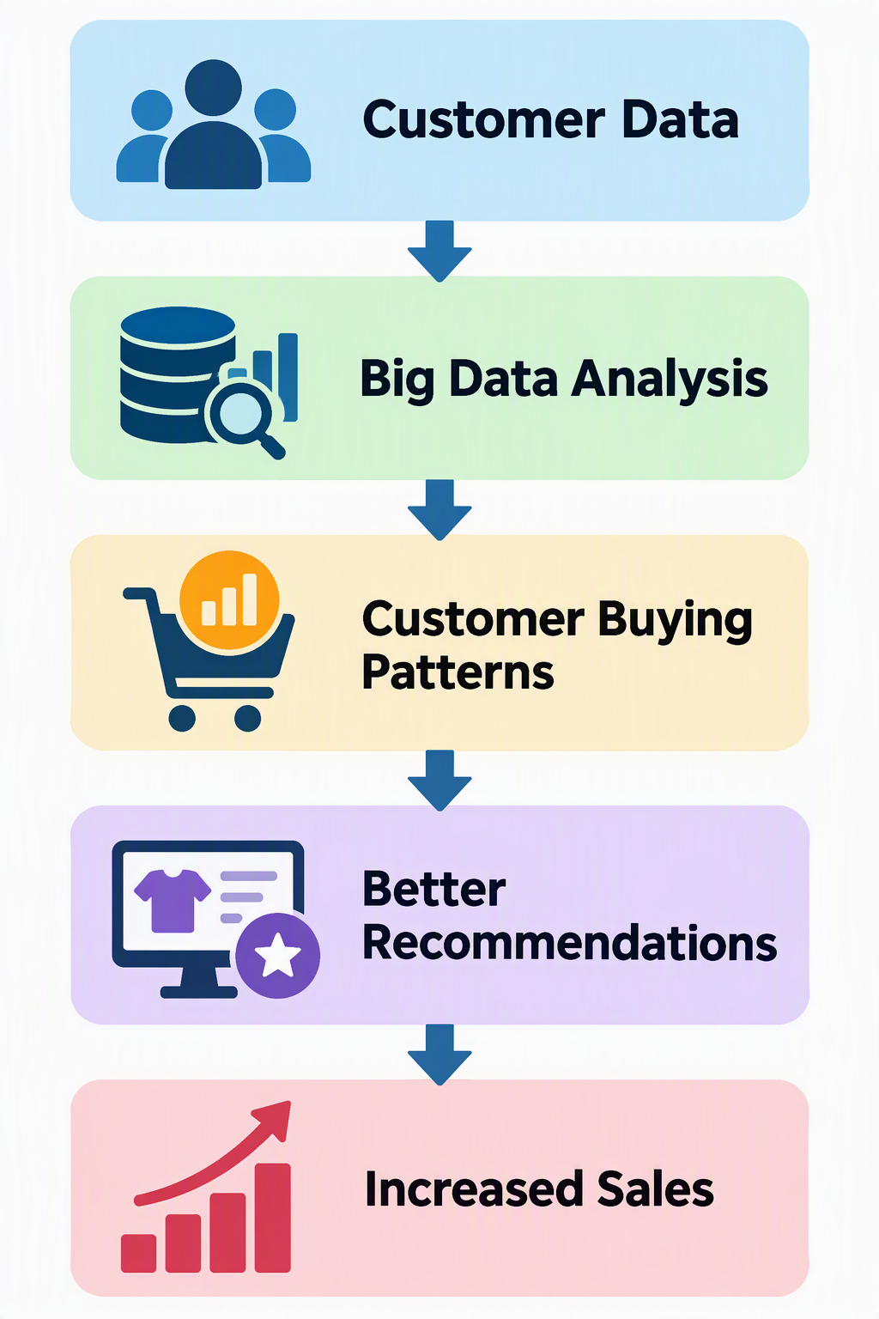
- Traditional vs Distributed Computing
Traditional Computing
In traditional computing, data is generally processed using a single computer or server, or a system whose processing is primarily scaled by increasing the resources of individual machine.
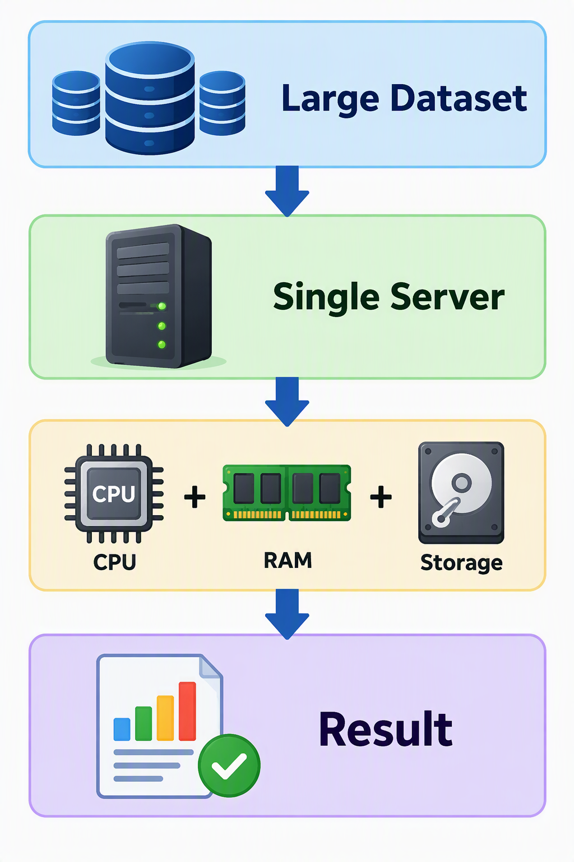
When the amount of data increases significantly, one machine may become expensive or insufficient.
This is commonly called vertical scaling, where resources are added to a machine.
Distributed Computing
Distributed Computing divides data & computational work across multiple connected computers.
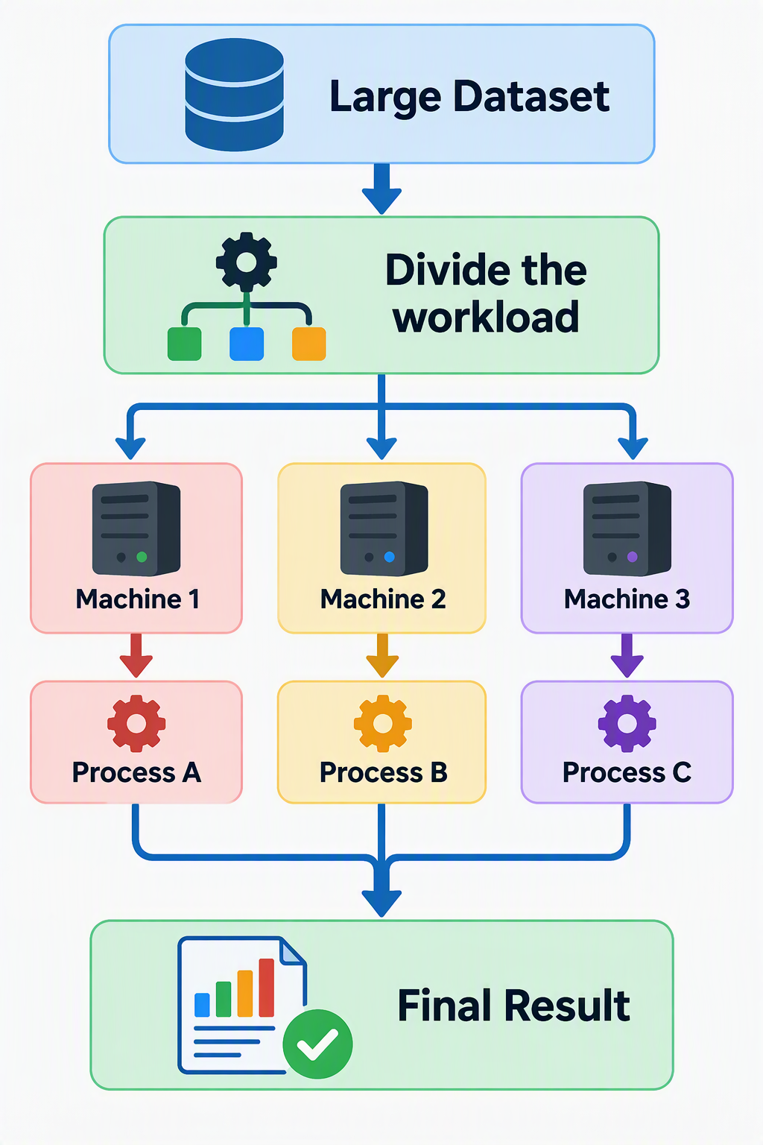
This allows multiple machines to process parts of the workload simultaneously.
Adding more machines is commonly called horizontal scaling.
Comparison between Traditional Computing & Distributed Computing
Traditional Computing | Distributed Computing
Processing concentrated on one/fewer machines | Processing distributed across multiple machines
Often scales vertically | Commonly scales horizontally
Hardware upgrades can become expensive | Commodity/cloud machines can be added
Single-machine capacity creates limits | Can handle much larger workloads
Failure of a critical machine can interrupt processing | Distributed frameworks can provide fault-tolerance mechanisms
Suitable for many small-to-medium workloads | Useful for very large datasets and parallel workloads

- Challenges of large-scale data processing
  - Storage
  - Processing Speed
  - Scalability
  - Fault Tolerance
  - Data Variety
  - Data Quality
  - Security & Privacy
  - Network Overhead
- Hadoop Ecosystem Overview
Apache Hadoop is an open-source ecosystem designed for distributed storage & processing of large datasets.
Simplified Hadoop Architecture
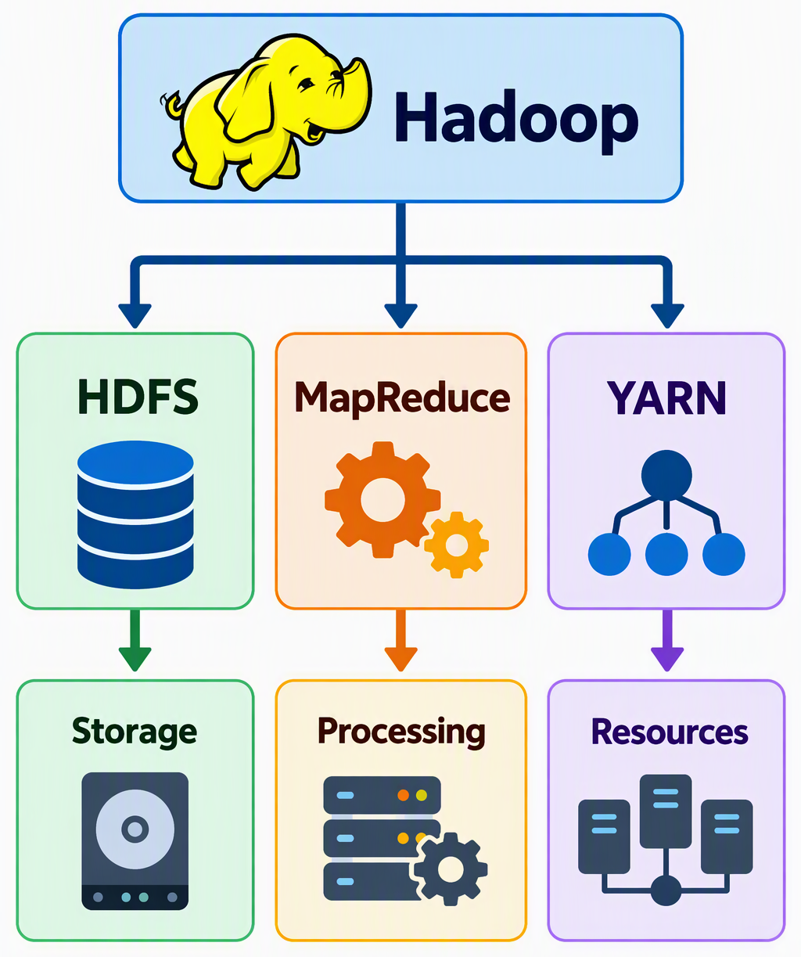
HDFS
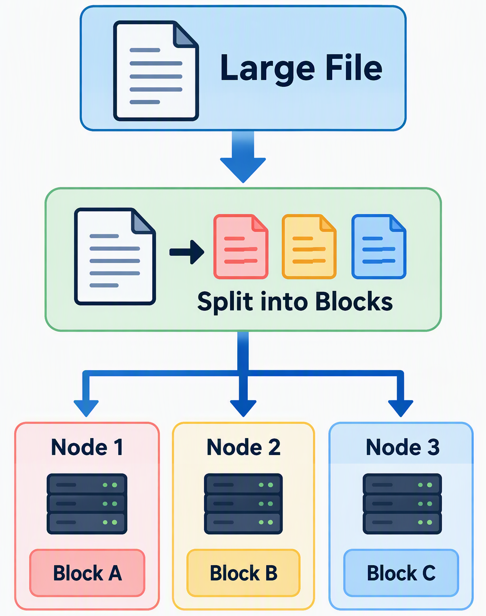
MapReduce
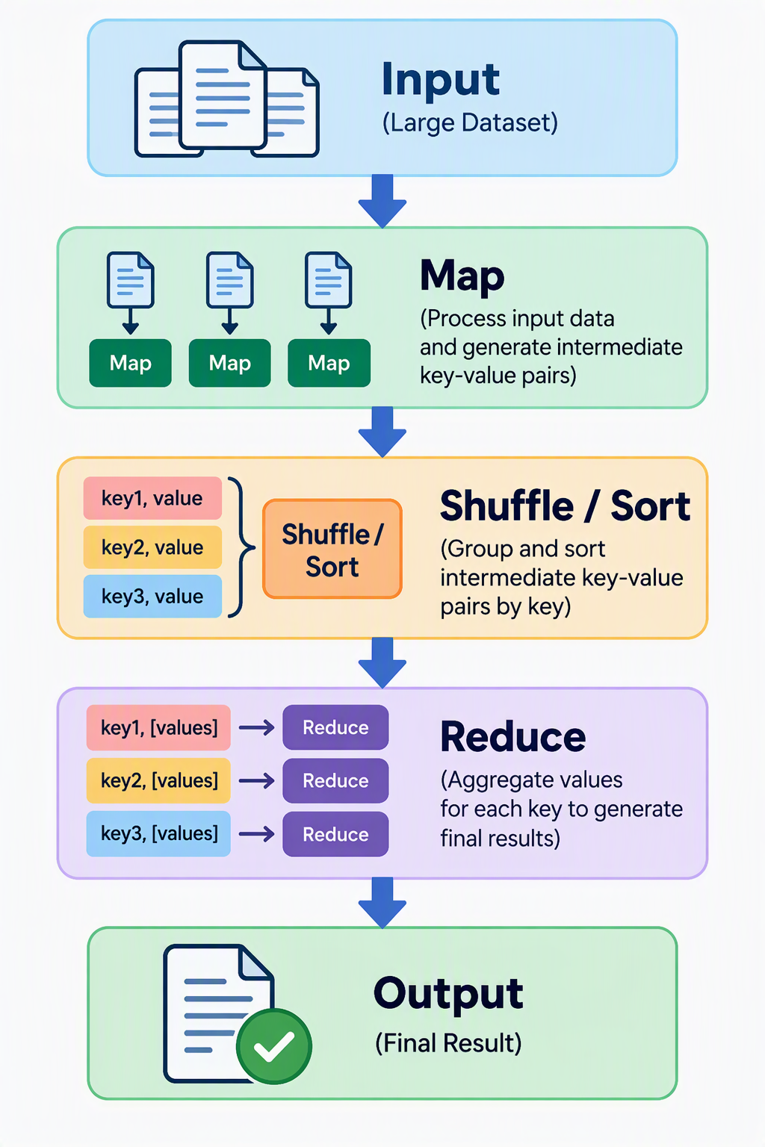
YARN – Yet Another Resource Navigator
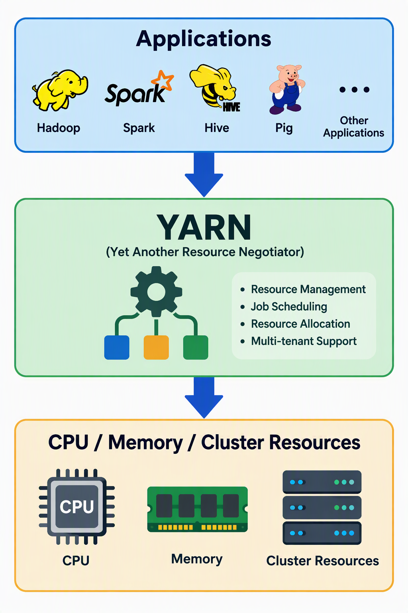
- Spark Ecosystem Overview
Apache Spark is an open-source distributed processing engine designed for large-scale data analytics. It can perform computations across multiple machines & supports a range of workloads through a unified ecosystem.
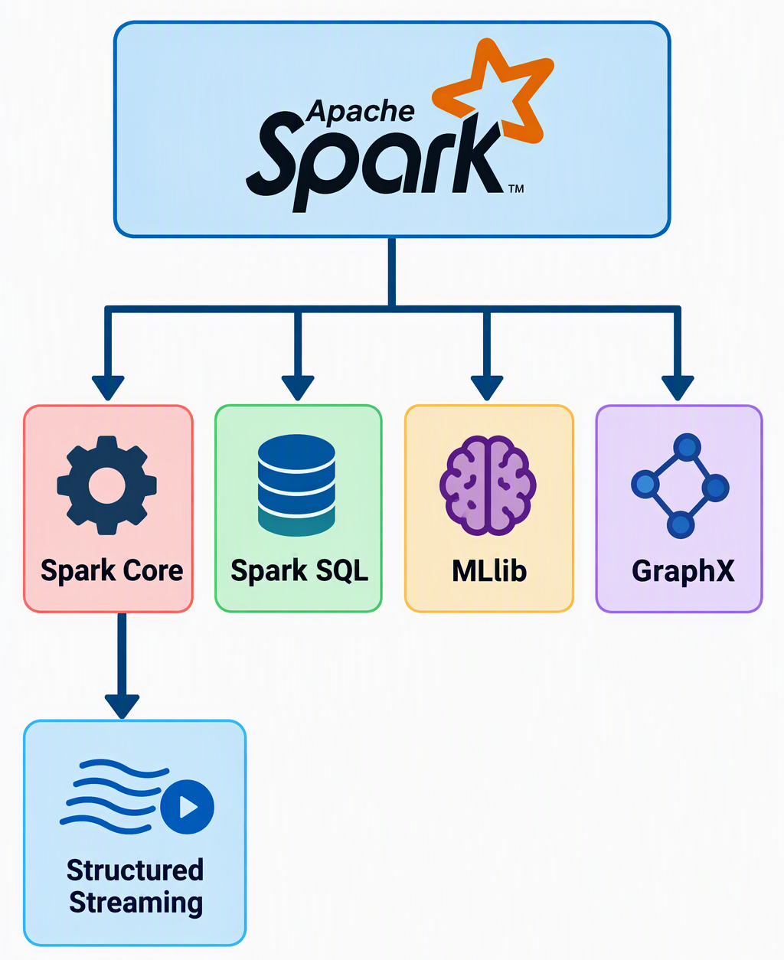

Hadoop vs Spark
Hadoop MapReduce | Apache Spark
MapReduce processing model | General-purpose distributed processing engine
Intermediate stages commonly rely heavily on disk | Can keep intermediate data in memory when beneficial
Strongly associated with batch processing | Supports batch, SQL, streaming, ML and other workloads
HDFS provides distributed storage | Spark can read from many external storage systems
YARN can manage resources | Spark can run with different cluster managers

Overall Big Data Flow
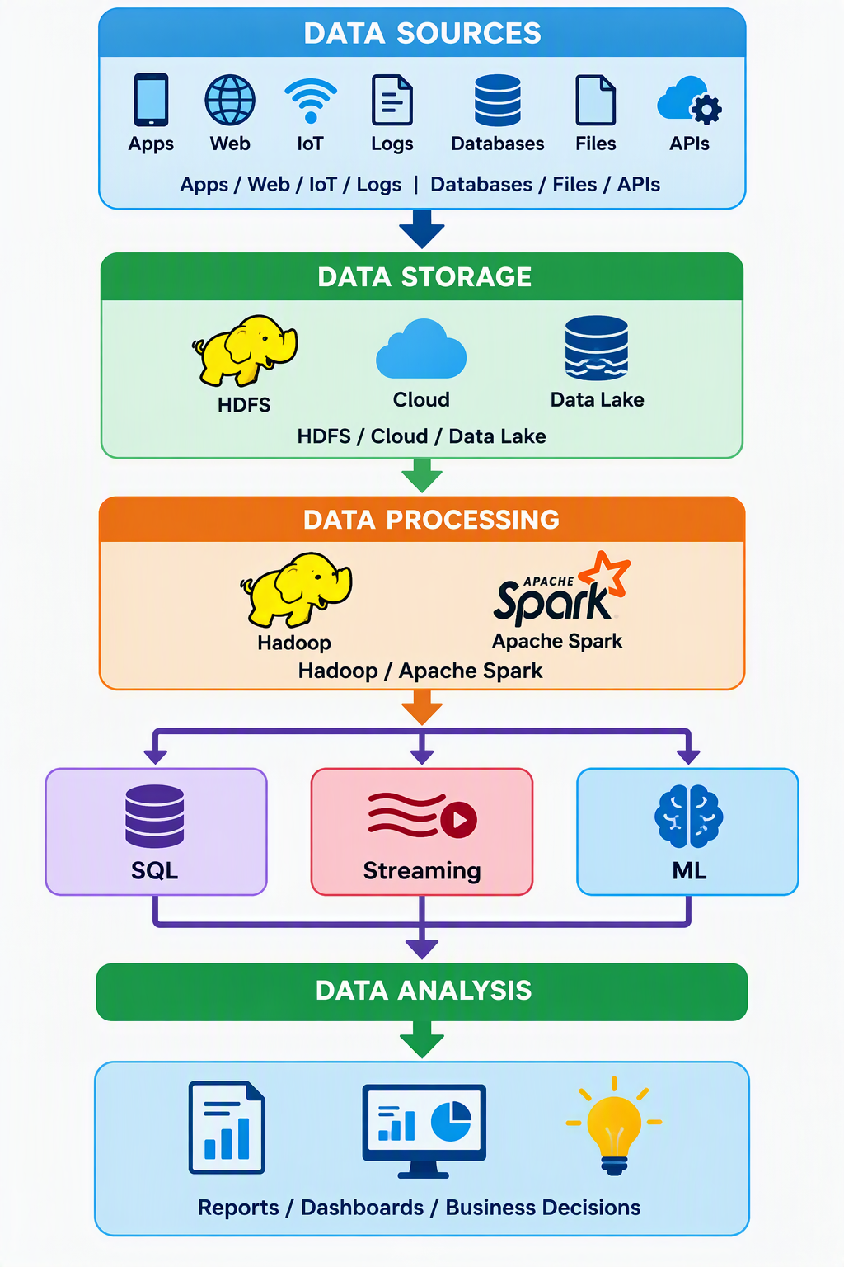
Apache Spark Architecture
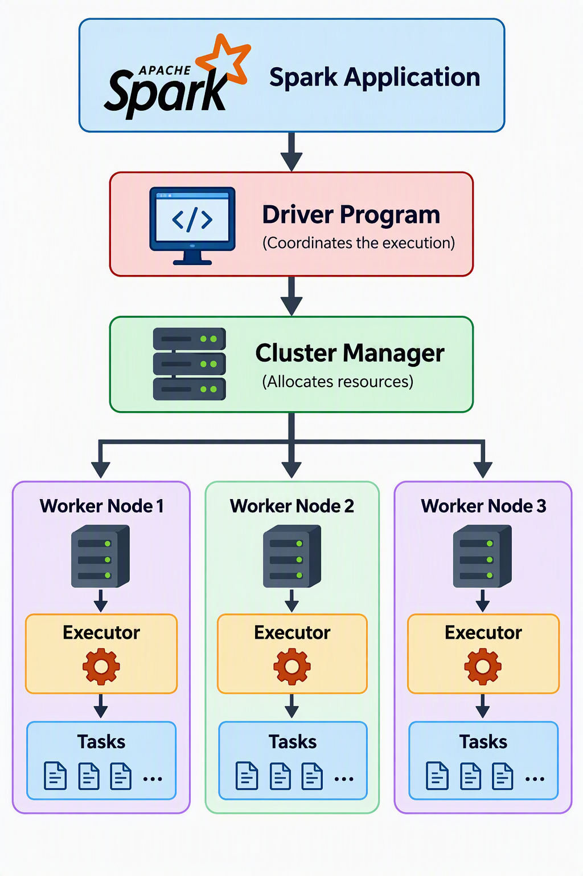
- Spark Components
  - Application
  - Driver Program
  - Cluster Manager
  - Worker Nodes
  - Executors
  - Tasks
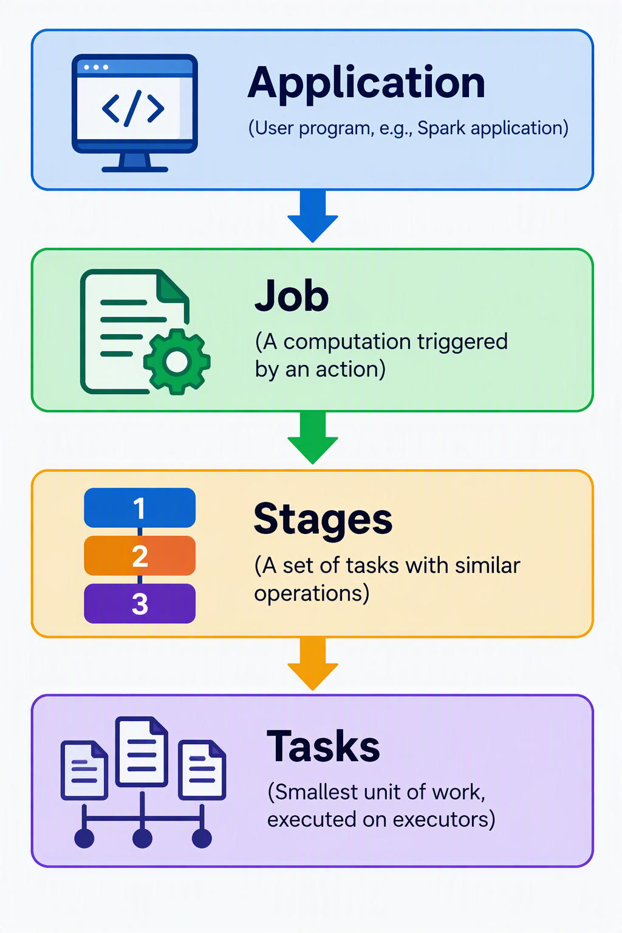
- Spark Cluster Architecture
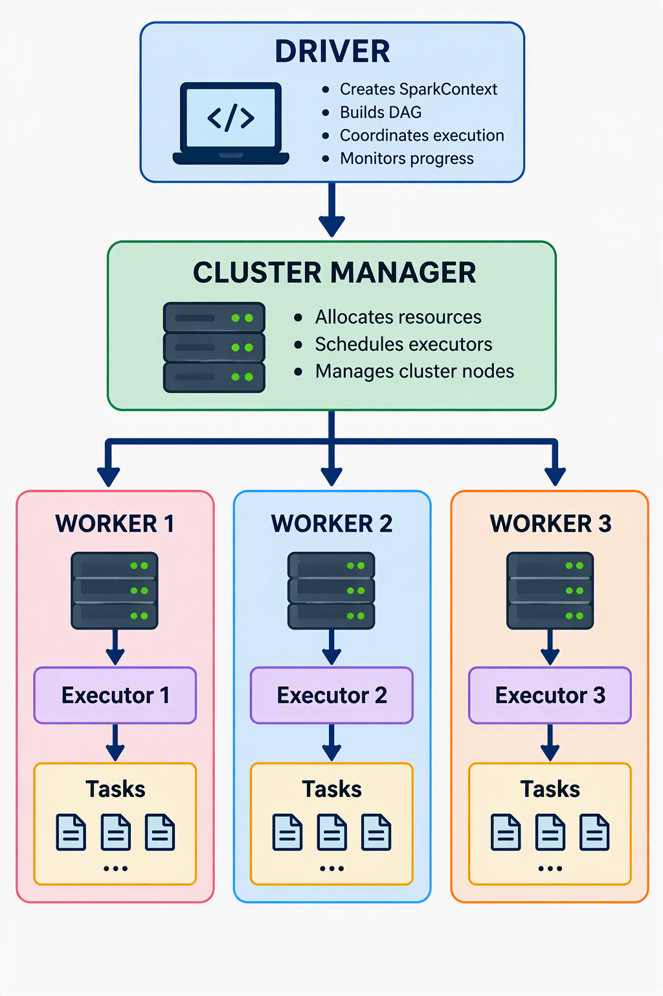
- Driver Program
The driver program is the main coordinating process of a spark application.
- Executors
Executors are processes launched for a spark application on cluster nodes.
- Cluster Manager
It is responsible for allocating cluster resources to Spark applications.
- Worker Nodes
A Worker Node is a machine in a cluster that provides computing resources for application execution.
Spark Modes
- Local Mode
- Standalone Mode
- YARN
Local vs Standalone vs YARN
Feature | Local | Standalone | YARN
Machines | One | Multiple | Multiple
Cluster required | No | Yes | Yes
Cluster manager | Local Spark process | Spark Standalone | Hadoop YARN
Setup complexity | Low | Moderate | Higher
Best suited for | Learning/testing | Dedicated Spark clusters | Hadoop environments
Distributed across machines | No | Yes | Yes
External Hadoop required | No | No | Yes

Getting Started with PySpark
Creating DataFrames
- From lists
- From CSV files
- From JSON files
- From Parquet files
DataFrame Basics
- show()
- printSchema()
- describe()
- count()
Hands-on
- Load employee dataset
- Explore schema
- Generate statistical summary
DataFrame Transformations and Actions
DataFrame operations can broadly be understood as Transformations & Actions.
Transformations
A transformation is an operation that takes an existing DataFrame & defines a new DataFrame from it.
Transformations generally do not immediately process all the data. Spark records the sequence of operations & builds an execution plan. This behaviour is called Lazy Evaluation.
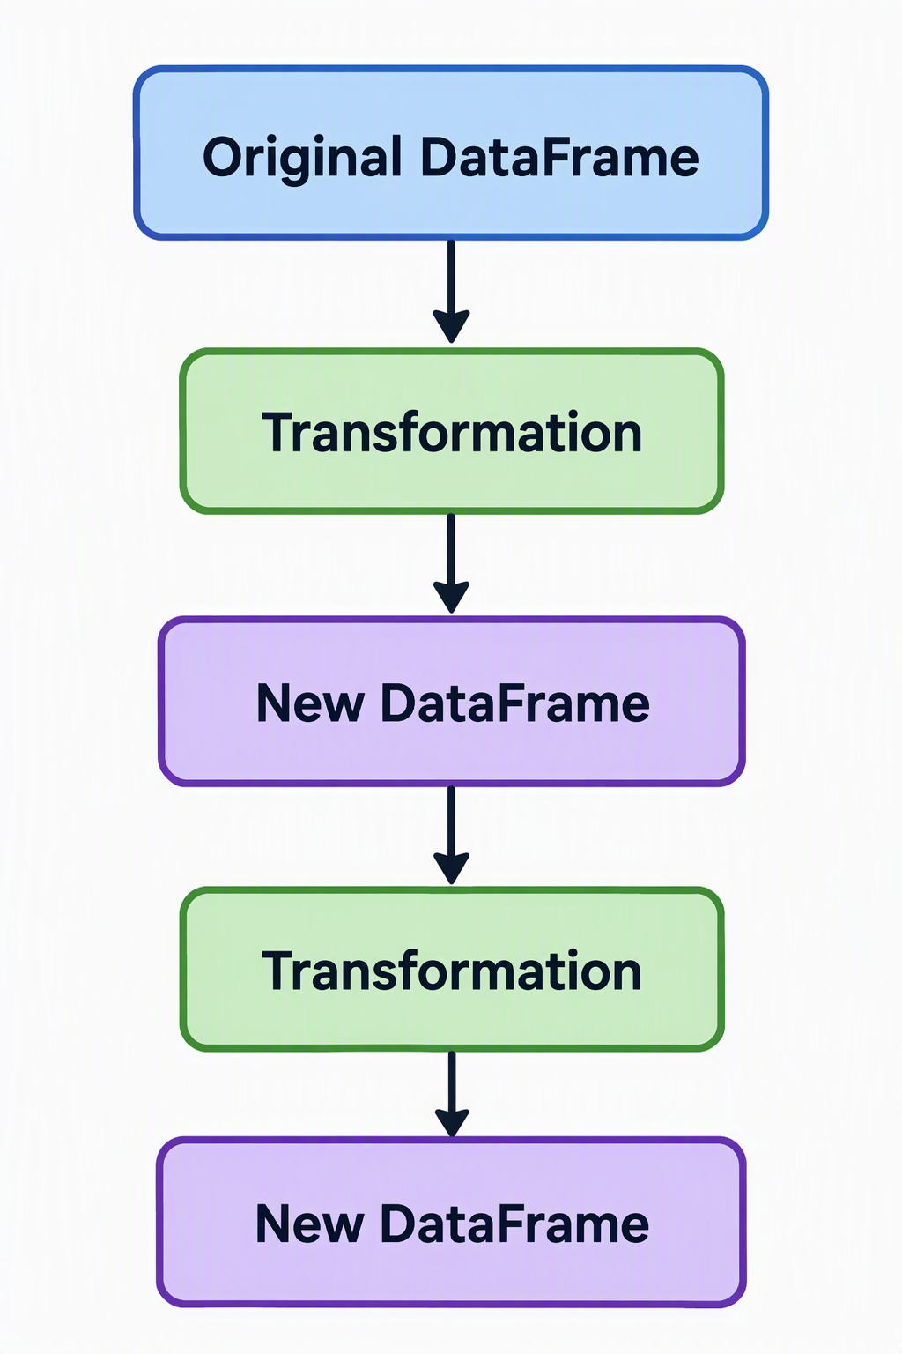
Common DataFrame Transformation
Transformation | Purpose
select | Selects required columns
filter / where | Selects rows based on a condition
withColumn | Adds a new column or changes an existing column
withColumnRenamed | Renames a column
drop | Removes columns
distinct | Removes duplicate rows
dropDuplicates | Removes duplicates based on specified columns or complete rows
orderBy / sort | Sorts data
groupBy | Defines grouping for subsequent aggregation
join | Combines DataFrames based on related columns
union / unionByName | Combines rows from DataFrames
limit | Defines a DataFrame containing a limited number of rows
repartition | Redistributes data into partitions
coalesce | Usually reduces the number of partitions
alias | Provides an alias for a DataFrame or expression

DataFrame Actions
An action is an operation that causes Spark to execute the required transformation & produce a result or observable output.
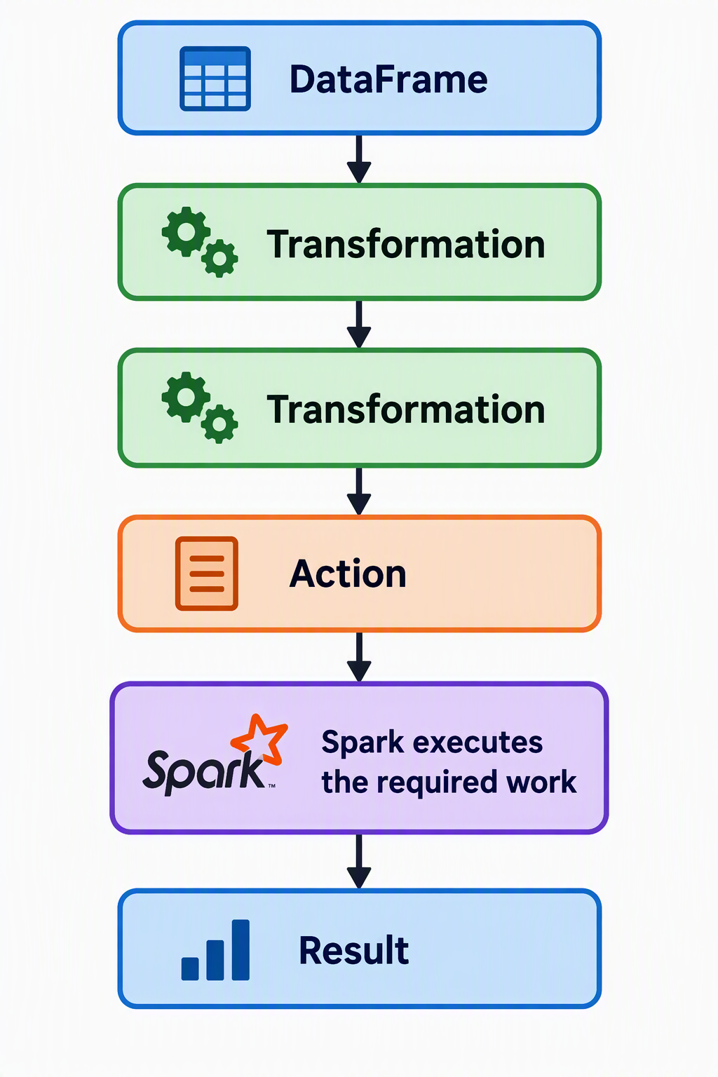
Common Actions
Action | Purpose
show | Displays DataFrame rows
count | Returns the number of rows
collect | Returns all rows to the Driver
first | Returns the first row
head | Returns the first row or requested number of rows
take | Returns a specified number of rows
foreach | Performs an operation for each row
write/save operations | Trigger computation to persist output

Narrow Transformations
A narrow transformation is one where each output partition can generally be computed from a limited number of input partitions without requiring a full redistribution of data across the cluster.
- filter()
- select()
- withColumn()
- drop()
Wide Transformations
A wide transformation may require data from multiple input partitions to be redistributed across the cluster.
- groupBy()
- join()
- distinct()

e.g.
Partition 1 → IT, HR, Sales
Partition 2 → HR, IT, Sales
Partition 3 → Sales, HR, IT
Calculate total salary by department
IT records → one set of target partitions
HR records → another set
Sales records → another set

Actions
- show()
- collect()
- count()
- take()
Column Functions
- col()
- lit()
- when()
- concat()
Hands-on — Employee Data Transformation
- Rename columns
- Create derived columns
- Filter employees
- Aggregate department information

